Why Use Quote Cards On LinkedIn?
A few reasons:
- They build credibility. Quoting experts positions you alongside them in your reader's mind.
- They're highly shareable. People love to repost wisdom that reinforces their beliefs.
- They extend your reach. The LinkedIn algorithm rewards posts with images.
With quote cards, you can share both your own insights and wisdom from others that your audience will appreciate. It's a simple way to add variety to your content mix.
Before we get to the 5 templates, let's talk about design.

Design 101 (For Non-Designers)
Full transparency:
I’m not a designer. But I have taste. I know what good design looks like when I see it. And I’m betting you do too. Whether it’s the clean lines on an Apple iPhone box, or the color-coded clarity of a Tokyo subway map—you recognize good design instantly.

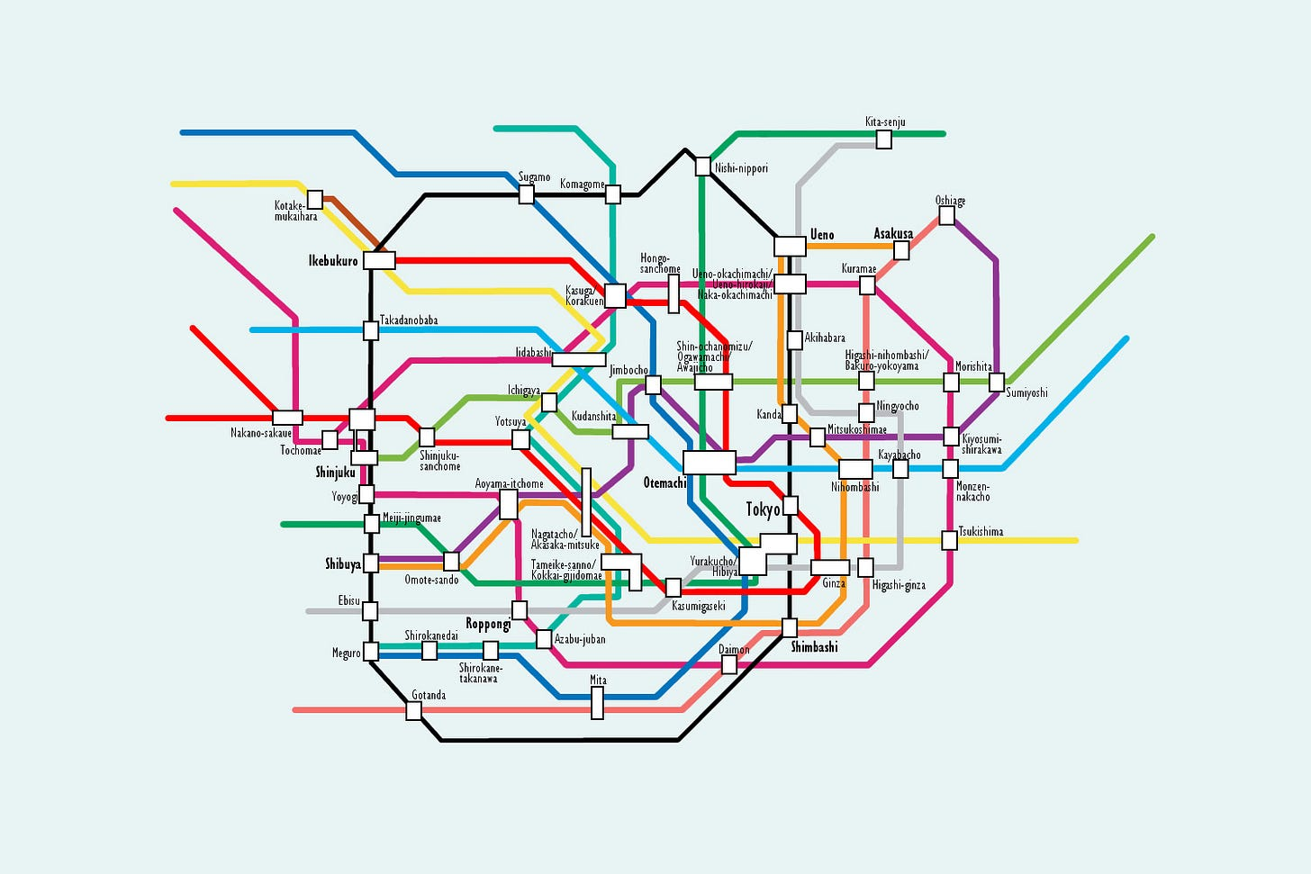

This is visual design at work.
And once a design friend pointed these principles out to me, I started seeing them everywhere. You can think of these as the "cheat codes" for non-designers.
Here are the 3 most important design elements you need to know when designing a quote card:
- Contrast (color & size) Contrast creates visual interest and guides the reader's eye to what matters. Dark text on light backgrounds (or vice versa) makes your quote instantly readable. Make the quote larger than the attribution to show what's most important. When someone glances at your card, contrast tells them exactly where to look first.
- Consistency (typeface & style) Consistency makes your designs feel intentional and builds your personal brand. Stick to 1-2 fonts maximum (one for headlines, one for body text). Choose a color palette of 2-3 colors and use them across all your cards. This is how people start recognizing your content before they even read it.
- Space (negative & alignment) The secret weapon of professional designers is how they use empty space. Don't fill every pixel—the "emptiness" makes your content feel premium. Line up elements along invisible grid lines and keep text away from edges to create breathing room. Professional designers know that what you leave out is just as important as what you put in.
Now, let's see how these principles translate into five specific quote card styles you can create with ChatGPT

5 Quote Card Styles For LinkedIn
Bringing your quote cards to life is easier than you think.
You have two options:
- Use ChatGPT-4o with image generation capabilities (the fastest method)
- Copy these prompts into DALL-E, Midjourney, or other AI image generators
For this guide, we’ll use ChatGPT.
Just plug in your preferences like brand colors, fonts, or images into each prompt.
I’ve included the exact prompts below so you can start creating right away.

Style 1: The Minimalist Wisdom Card

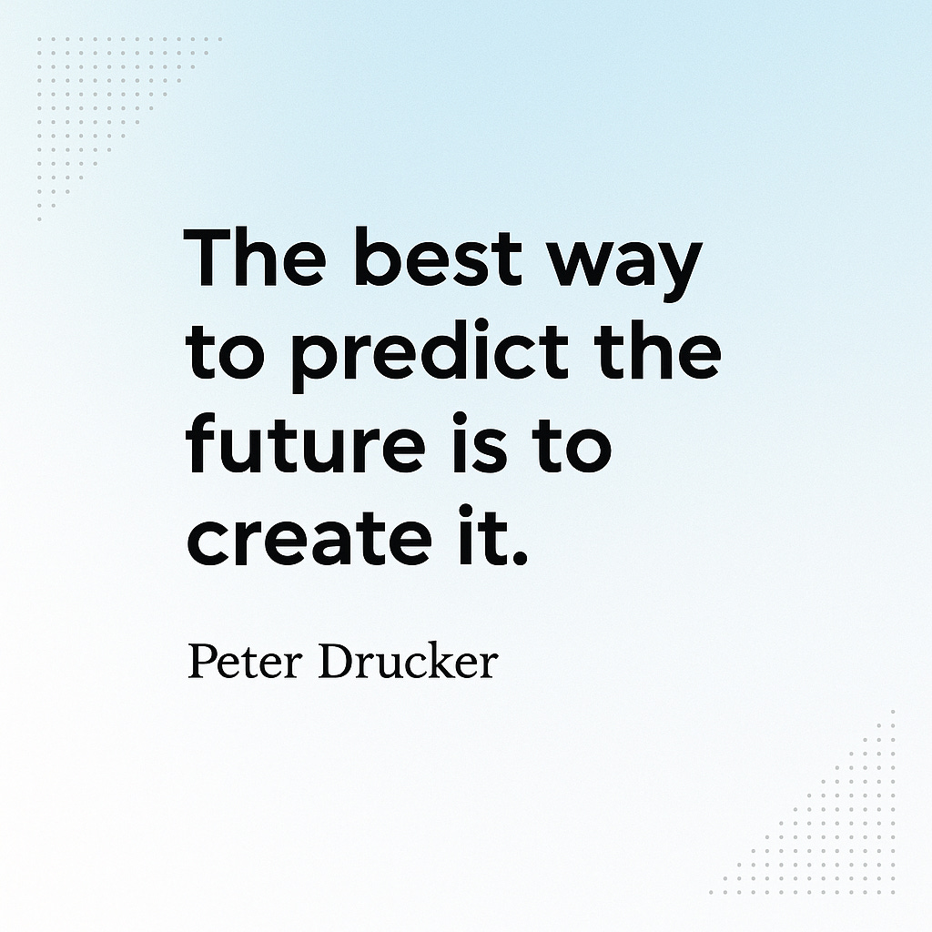

This style uses one bold statement on a clean background.
Perfect for short, powerful quotes.
AI Prompt:
Create a minimalist quote card design with:

- A light blue to white gradient background
- The quote "INSERT QUOTE" by AUTHOR
- Use Montserrat for the quote (bold) and Georgia for the attribution (regular)
- Add subtle dot patterns in the corners
- Size: 1200x1200px square format for LinkedIn
Pro tip: For the best results, keep your quotes under 20 words. The more concise your message, the more impactful the minimalist design will be.

Style 2: The Two-Tone Split

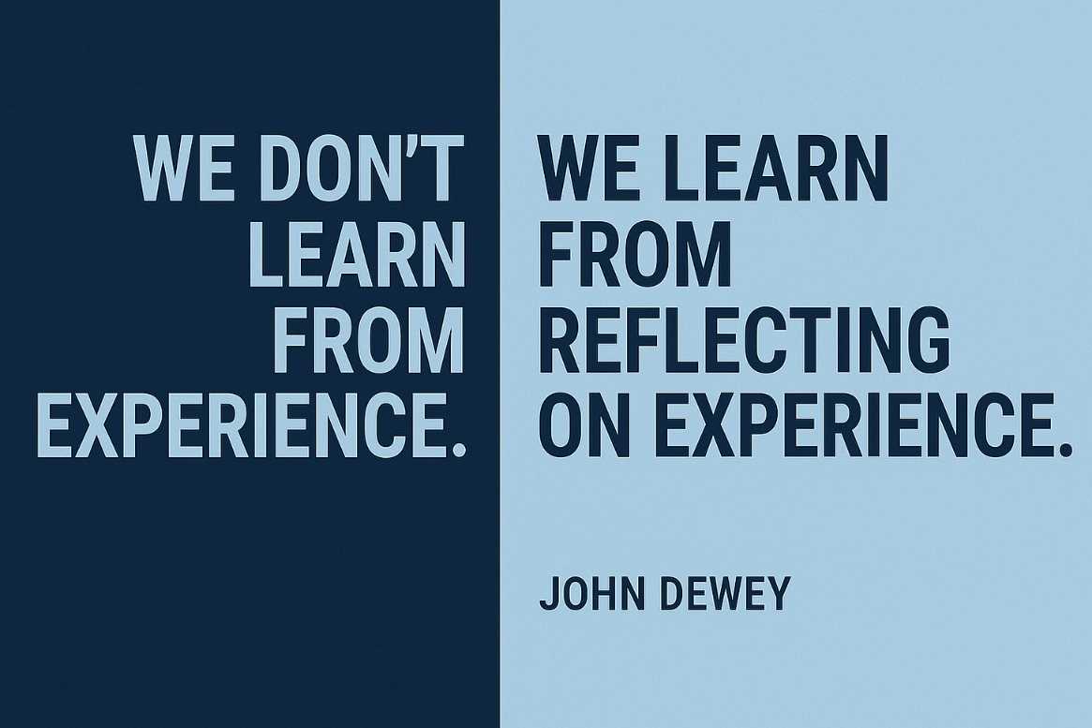

This style divides your image into two distinct color sections, creating visual tension that immediately draws the eye.
AI Prompt:
Design a two-tone split quote card:

- Left side dark navy, right side light blue
- The quote
(left side) "INSERT QUOTE"
(right side) "INSERT QUOTE" by AUTHOR
- Use duotone inverse split sans-serif font (Roboto) for the quote
- Place attribution in small text at bottom right
- Add a small white line dividing the two colors
- Size: 1200x628px rectangle format for LinkedIn
This style works well for compare/contrast ideas or before/after concepts.
You can customize the colors to match your personal or company branding for consistent visual identity across your posts.

Style 3: The Photo Overlay

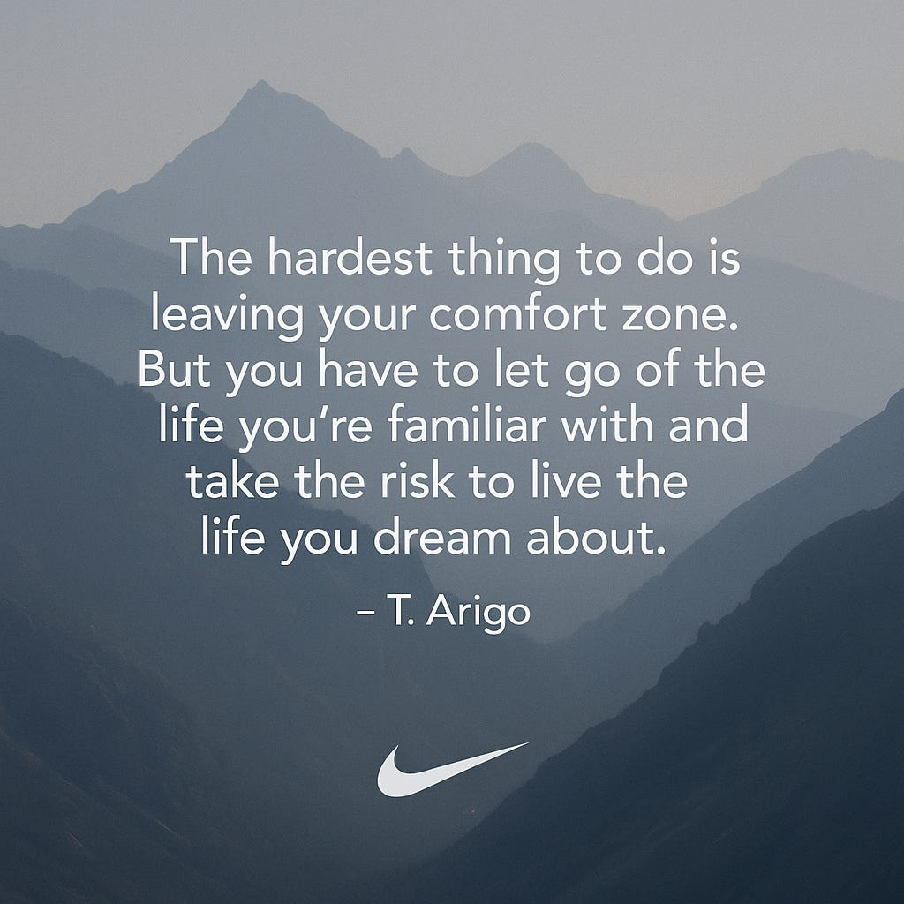

This style places text over a relevant image, creating emotional resonance.
AI Prompt:
Create a quote card with a photo background:

- Use a subtle image of mountains with low opacity/filter
- The quote "The hardest thing to do is leaving your comfort zone. But you have to let go of the life you're familiar with and take the risk to live the life you dream about." by T. Arigo
- Use white text with drop shadow for readability
- Add a semi-transparent dark overlay to make text stand out
- Include your logo or name in bottom corner
- Size: 1080x1080px square format for LinkedIn
When using this style, choose images that reinforce your message rather than distract from it. Abstract images often work better than busy scenes, as they provide texture and emotion without competing with your text.

Style 4: The Icon Enhancer

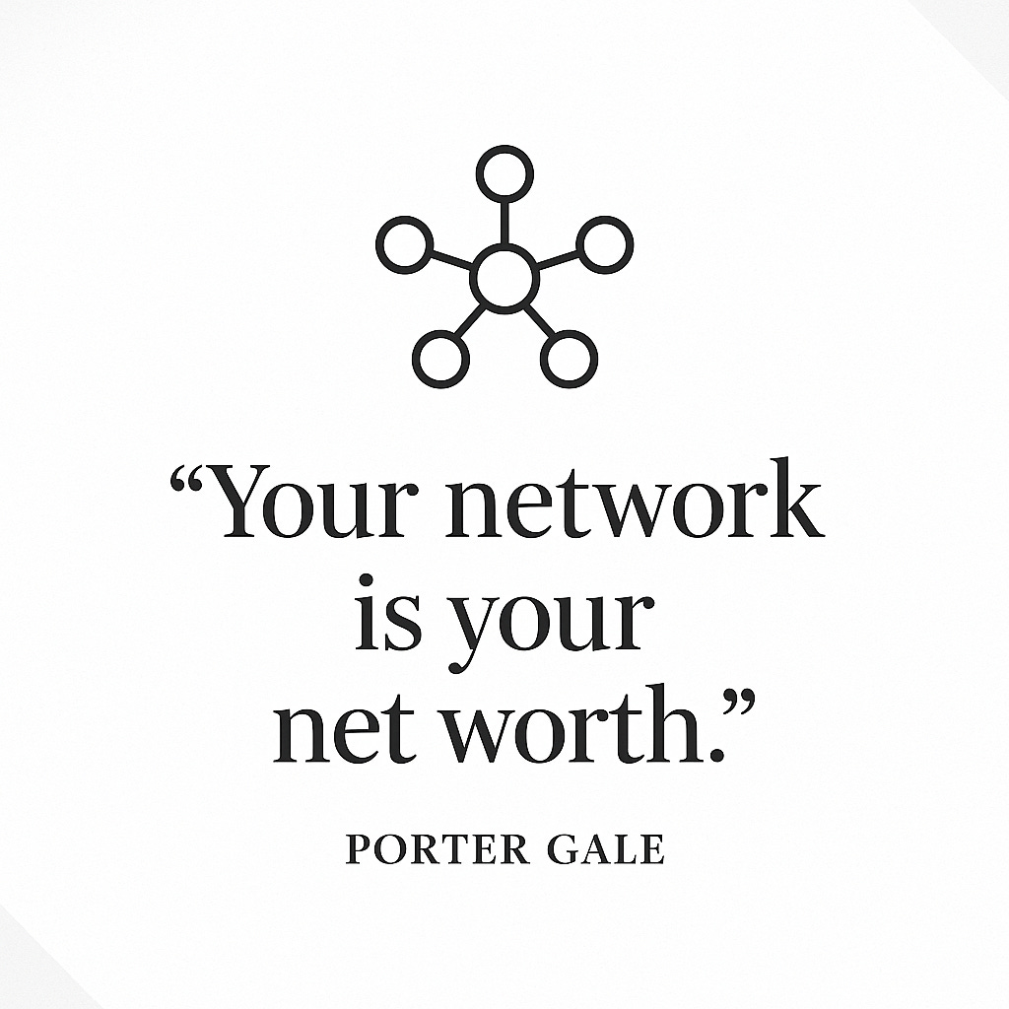

This design pairs the quote with a relevant icon to reinforce the message.
AI Prompt:
Design a quote card with complementary icon:

- Clean white background with light gray corner accents
- The quote "Your network is your net worth." by Porter Gale
- Include a simple line-art style icon of connected nodes/network
- Use dark charcoal text in Playfair Display font
- Place icon above the quote, sized at 25% of the canvas
- Size: 1200x1200px square format for LinkedIn
This style is particularly effective for list-based content, step-by-step processes, or quotes that contain distinct concepts that can be represented visually.

Style 5: The Data Visualizer

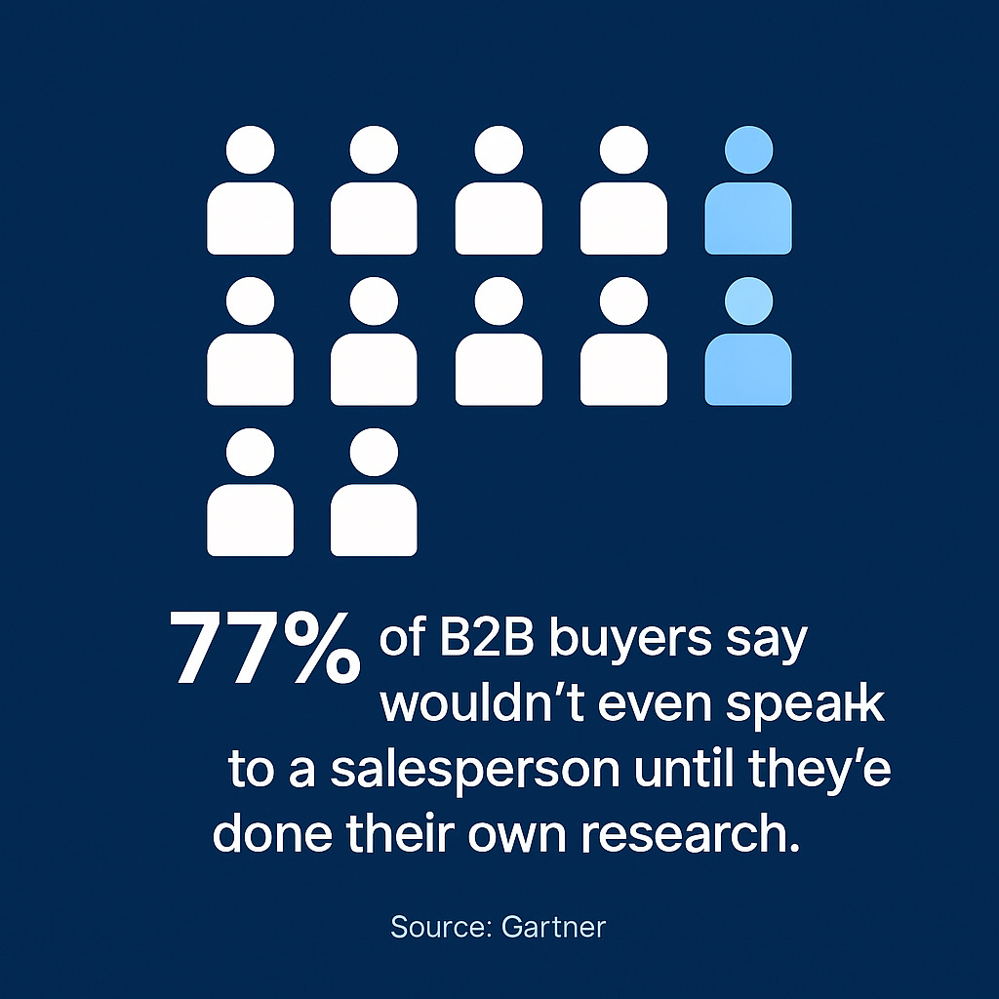

This style turns a statistic or data point into a visually compelling card.
AI Prompt:
Create a data visualization quote card:

- Background in professional navy blue
- The statistic "77% of B2B buyers say they wouldn't even speak to a salesperson until they've done their own research" from Gartner
- Visualize this with a simple human icon chart (77% colored differently)
- Use clean sans-serif font in white
- Include source attribution in small text
- Size: 1080x1080px square format for LinkedIn
The key to this style is simplicity - focus on one main data point rather than trying to cram multiple statistics into a single image.

How To Find Quotes For A LinkedIn Post
First, spend 2 minutes listing 10-15 keywords that would make your ideal client stop scrolling.
The key here is coming up with a set of words your target audience will clue into visually when scanning their feed.
For example, if write about leadership, your keywords might include:
- 1:1’s
- Hiring
- Leadership!
- Making decisions
- How to have difficult conversations
Now you’ve got a lens to find quotes that resonate.
Once you have your keywords, start searching for quotes.
You have several options:
- ChatGPT Simply prompt: "Give me 10 powerful quotes about [keyword] from industry leaders in [your niche]"
- Perplexity Search: "Best quotes about [keyword] for business professionals"
- Google Search: "[keyword] quotes by successful [industry] leaders"
Look for quotes under 30 words and from recognizable names
This keeps them skimmable—and boosts credibility.

3 More Sources For Your Quote Cards
Don't just recycle the same quotes everyone uses.
Here are three places to find fresh material:
- Pull quotes from your own content. Transcribe your podcast or YouTube videos and extract the best lines. This creates a content flywheel that drives traffic back to your longer-form content.
- Create custom "meme quotes." Take a common phrase and add your unique twist. "Good things come to those who wait" becomes "Good CLIENTS come to those who DEMONSTRATE."
- Quote your clients or colleagues. This builds goodwill and expands your reach to their networks when they reshare.

How To Make Your Quote Cards 10x More Valuable
The biggest mistake people make is posting a quote and calling it a day.
Don’t do that.
Instead, add your personal experience.
- Challenge it. Do you agree? Disagree?
- Tell a story. When has this quote shown up in your life or work?
- Apply it. What does this mean for you, your industry, or your clients?
The quote isn’t the value.
Your insight is.
That's it for today!

